**DAILY ONLINE ACTIVITIES SUMMARY**

|  |  |  |  |  |  |  |  |
| --- | --- | --- | --- | --- | --- | --- | --- |
| **Date:** | | **29/05/2020** | | | | | |
| **Name of the Faculty** | | **Sayeesh** | | | | | |
| **No. of Students Allotted for monitoring** | | | | | **19** | | |
| **Progress** | | | | | **15** | | |
| **Whether collected report from all the allotted students** | | | | | **Yes** | | |
| **Online Test Summary** | | | | | | | |
| **Subject** |  | | | | | | |
| **Semester** |  | | | **Duration** | |  | |
| **No. of students Taken** | | |  | **Passing %** | |  | |
| **Certification Course Summary** | | | | | | | |
| **Course** | | **Secure Your Computer Network Servers And Clients From External Threats, With This Free Network And Security Course. (2 Modules Completed)** | | | | | |
| **Certificate Provider** | | **Alison** | | | **Duration** | | **15 Hours** |
| **Coding Challenges** | | | | | | | |
| **Problem Statement: 1. Write a Java Program to check whether the given number is Armstrong number or not**   1. **Write a Java Program to find longest substring without repeating characters in a string.** | | | | | | | |
| **Status: 29 students executed.** | | | | | | | |
| **Uploaded the report in Github** | | | | | **Yes** | | |
| **If yes Repository name** | | | | | <https://github.com/orgs/alvas-education-foundation/teams/sayeesh> | | |
| **Uploaded the report in slack** | | | | | **Yes** | | |

Online Test Details: (Attach the snapshot and briefly write the report for the same)

Certification Course Details: (Attach the snapshot and briefly write the report for the same)

Coding Challenges Details: (Attach the snapshot and briefly write the report for the same)

**Certification Course Summary** Completed the course in **Secure Your Computer Network Servers and Clients from External Threats, With This Free Network and Security Course. (2 Modules Completed)**

# 

**Attended Skycampus Digital Knowledge Series - Season 7**

*Hosted by ICT Academy, G. Saravanan (Moderator), Dr. Madhusudan Singh* (Morning 11 to 12)

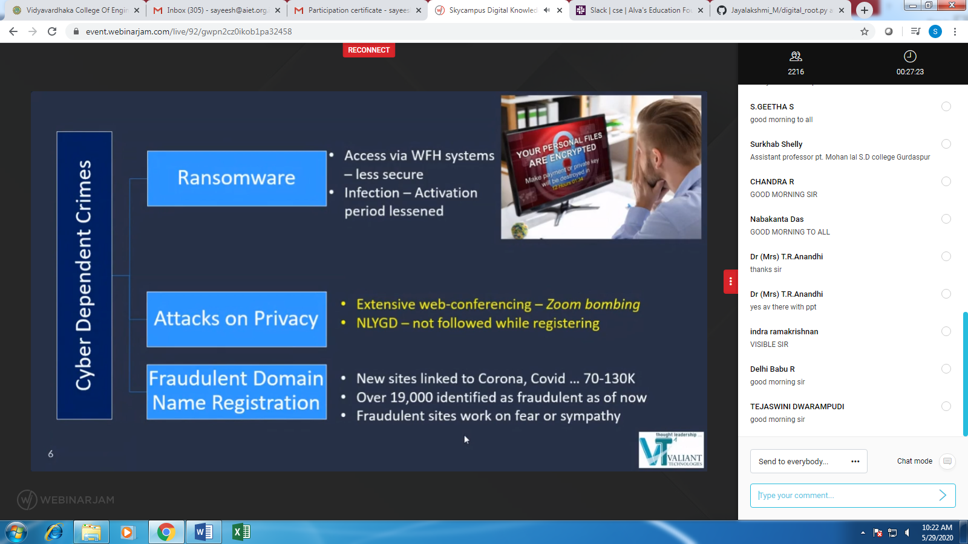

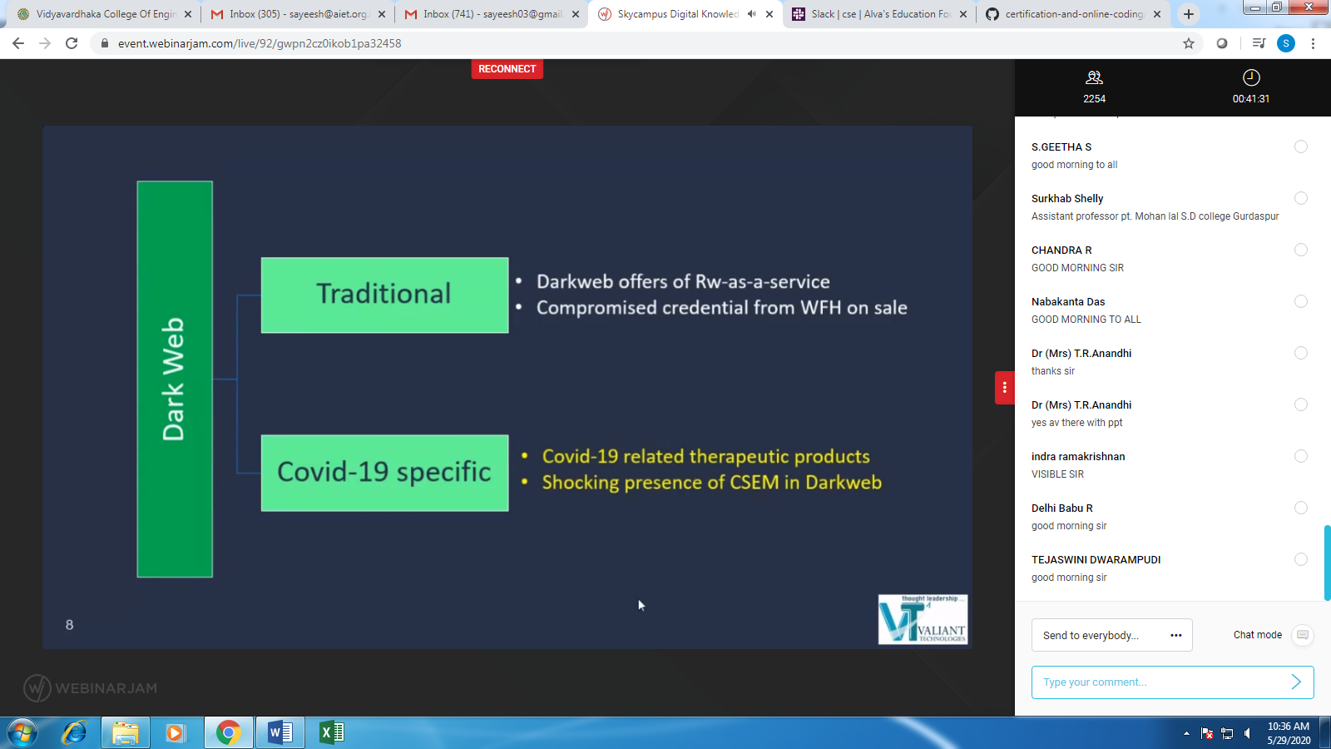

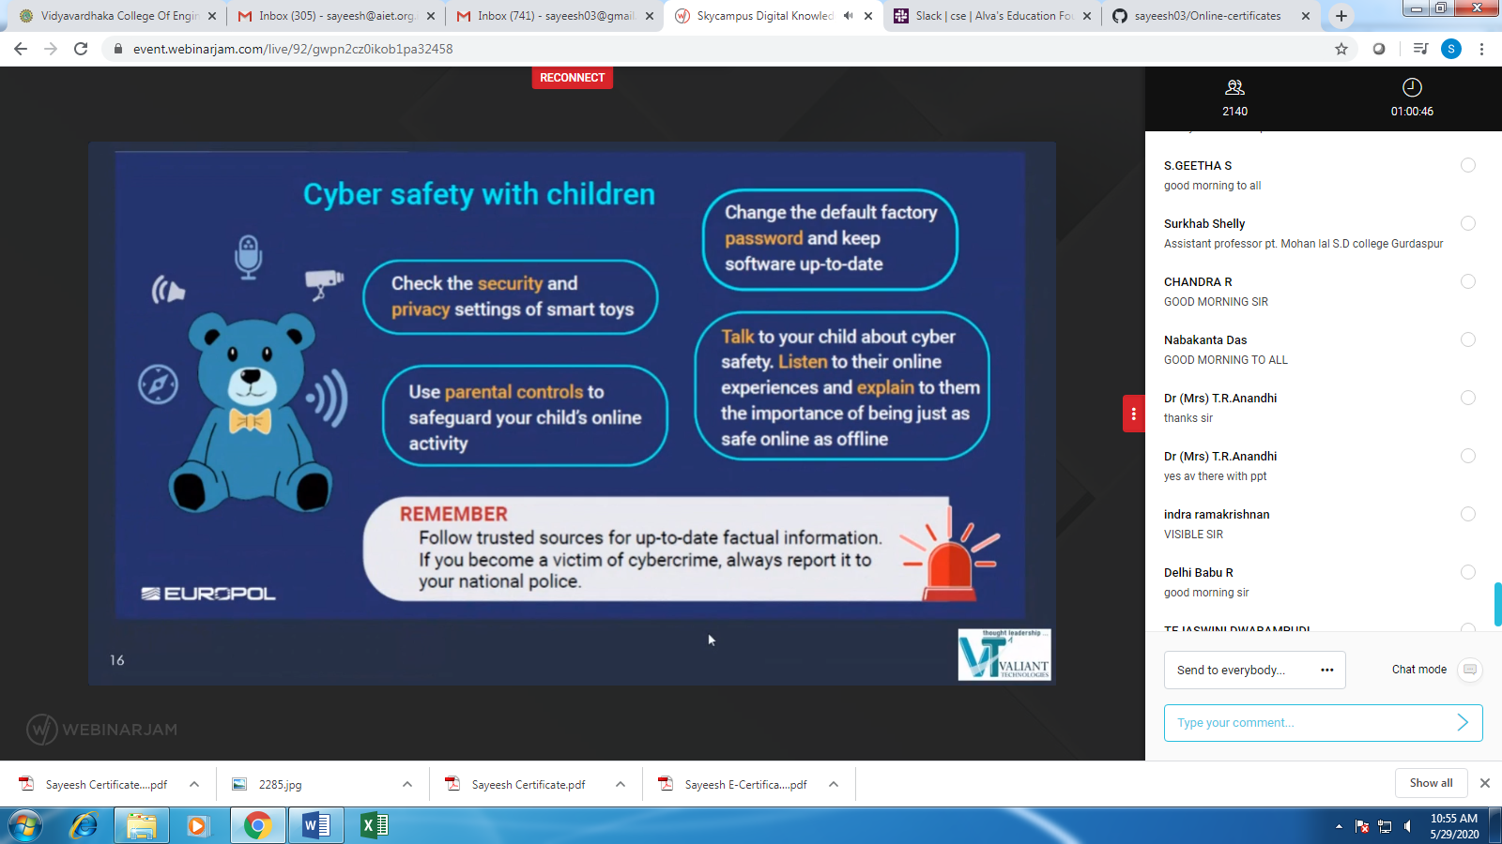

**Attended Faculty Development Program on “Networks & Security “**

**(Morning 11.00 to 1.00)**

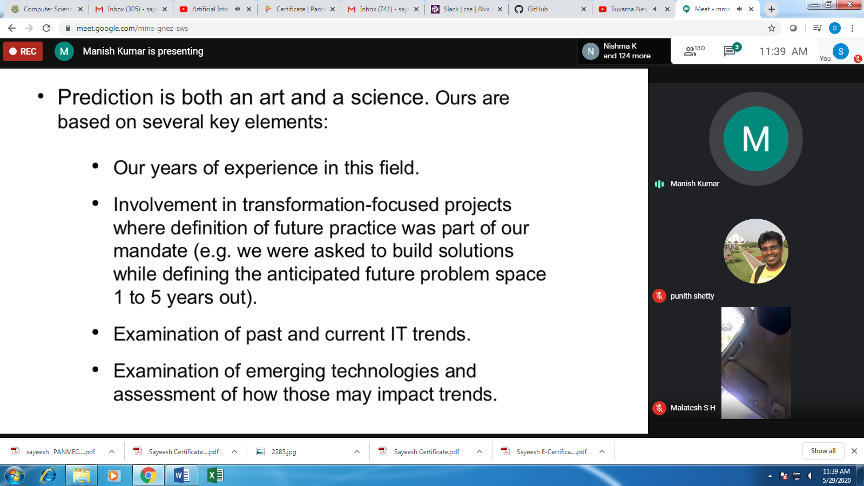

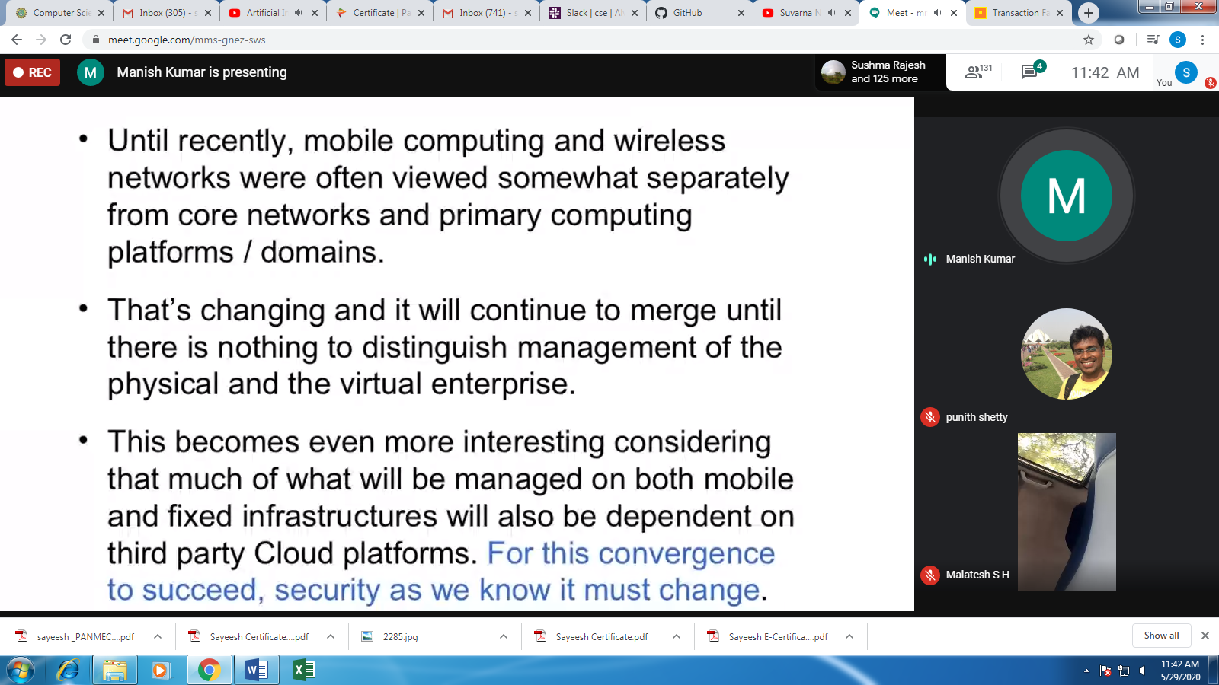

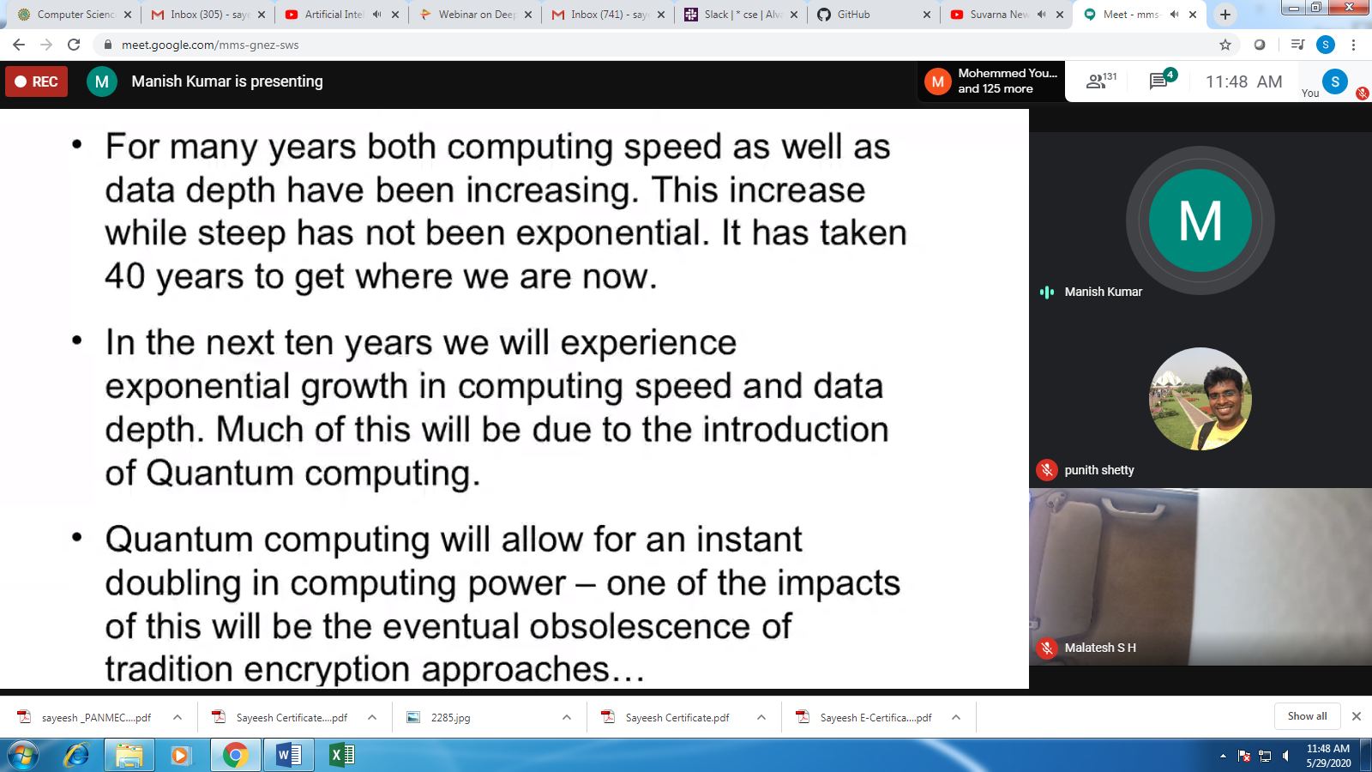

Today’s Java Problem Given:

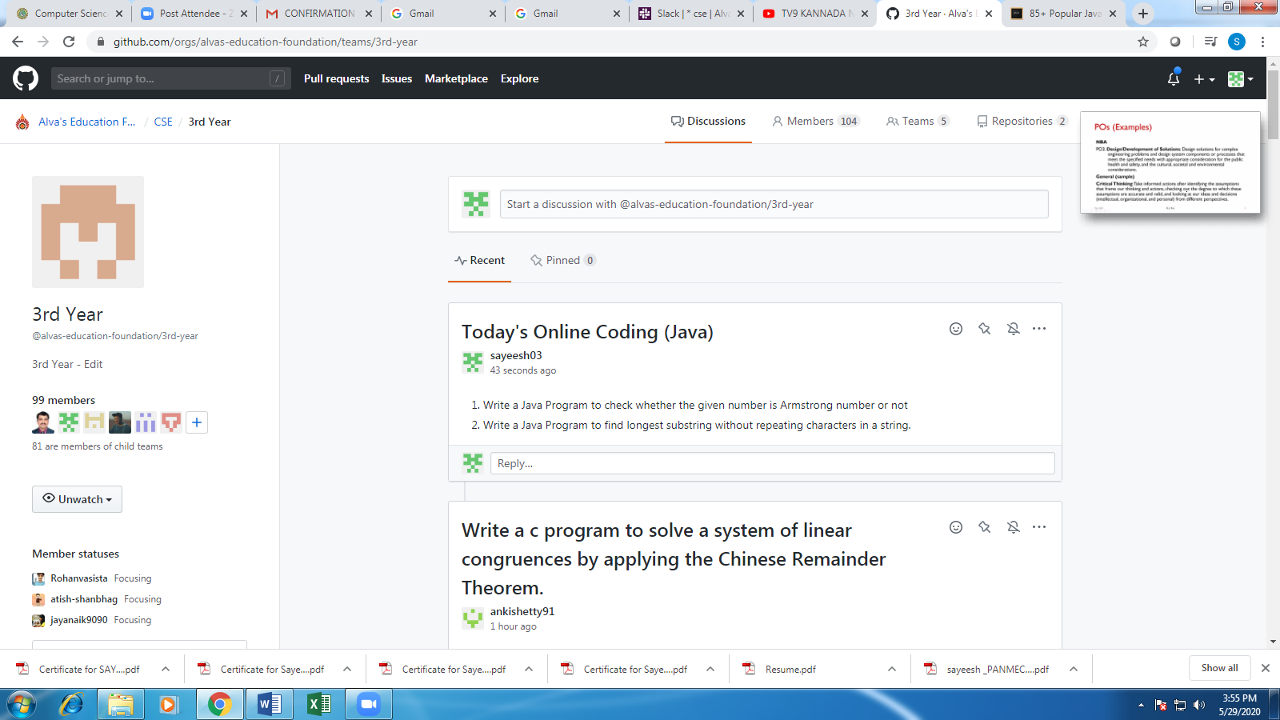

**Students Report:**

